
Umpire’s Report Form - Indoor

EVENT……………………………………… (Heat No… / SF … /Final)
Competitor Number: ………. Lane/Hip No:…… Lap No:…….

UMPIRING POSITION No:…………..
Umpire’s Name:………………..………. Signature:…………….……..

Rule No: | Description:
TR 6.3 | Received assistance (Give full details on reverse)  Referee note: use rule TR 7.1 & state appropriate subsection of TR 6.3 when informing PF
TR 7.1 | Unsporting manner ☐ improper conduct ☐ (Give full details on reverse)  Referee note: YC/YRC/RC. State reason when informing PF
TR 17.1.2 | Jostling ☐ Obstruction ☐ Impeded Athlete No............. (Give details on reverse)
TR 17.2.3 | (Races or part thereof in lanes) Ran over left lane line completely for …… step(s).  Ran on the line for 2 or more steps. Number of steps……
TR 17.2.4 | (Races not in lanes)  Ran over kerb or line marking inside border on bend for 2 or more steps. Number of steps:….  Ran on kerb or line marking inside border on a bend for 2 or more steps. Number of steps:…
TR 17.3.2 | Lane infringement on straight with material advantage ☐  Lane infringement on outer line on bend with material advantage ☐
TR 17.3.3 | (Races or part thereof in lanes) Ran on left lane line once  Referee note: “L” applied for touching the line once: YES/NO  DQ 17.3.3 applied for 2nd infringement of this rule (not in same race): YES/NO
TR 17.3.4 | Ran on or over kerb or line marking insider border for ONE step  Referee note: “L” applied for touching/stepping over the kerb/line once (1st instance): YES/NO  DQ 17.3.4 applied for 2nd infringement of this rule (not in same race): YES/NO
TR 17.6 | Continuing in the race after voluntarily leaving the track on Lap No......
TR 22.6 | Not going over each hurdle. Flt No........
TR 22.6.1 | Foot or leg is below the horizontal plane of top of hurdle (trailing leg). Flt No........
TR 22.6.2 | Knocking down ☐ or displacing ☐ a hurdle by hand, body or front side of the lead leg
TR 22.6.3 | Knocking down ☐ or displacing ☐ a hurdle in their or in another lane causing obstruction / affecting other athlete
TR 44.6 | Leaving assigned lane before the breakline
 | Other Infringement/incident ☐ / More information ☐: details on reverse
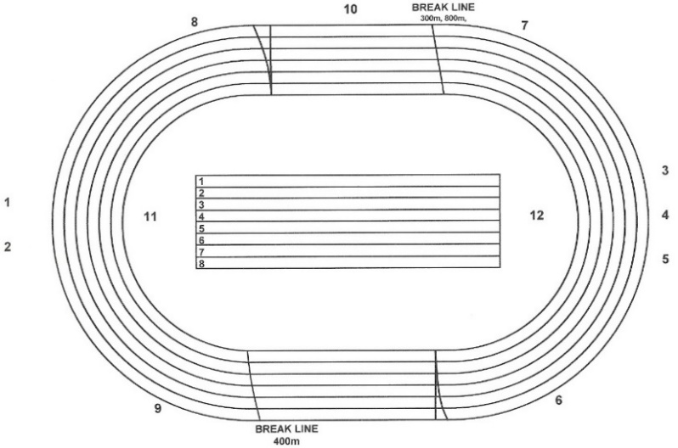
Please indicate on track plan the exact position of the infringement/incident

