 Umpire’s Report Form – World Para Athletics Rules (March 2024)

UNIVERSAL RELAY

Heat No: UMPIRING POSITION No.: ………………..
Semi-final No: Umpire’s Name………………………………..
Final: Signed ………………………………..

Team No./Name: ……………………..…………. Lane No.: ………………..

Take-over 1 2 3 / Leg No. 1 2 3 4 (circle appropriate option)

Rule No: | Description:
2.13.5 | Unsporting manner ☐ improper conduct ☐ (Give full details on reverse) Referee note: YC/YRC/RC.
5.4 (c) | Athlete and/or guide failed to complete with bona fide effort (Give full details on reverse)
6.15.3 | Tether breaks during race
7.3 (f) | Receiving physical assistance from other athletes making forward progression
7.9.5 | Failure to comply with tether rule: releasing tether before finish ☐ shortening tether ☐
7.10.4 | Failure to comply with rule 7.10: guide pushing athlete ☐ pulling athlete ☐ propelling athlete ☐ sling-shotting ☐ (Give details of when/where on reverse)
18.1 | Impeding another athlete after exchange Impeded Athlete No............. (Give details on reverse)
18.2 (c) | Ran ☐ wheeled ☐ over left lane line completely for …… step(s) / push(es).  Ran ☐ wheeled ☐ on the line for 2 or more steps/pushes . Number of steps/pushes……
18.5 (c) | Ran ☐ wheeled ☐ on left lane line once  Referee note: “L” applied for touching the line once: YES/NO  DQ 18.2 (c) applied for 2nd lane infringement by any team member in any round of same event: YES/NO
18.3 | Propulsion of wheelchair other than by pushing on wheels or push-rims
23.6 | Failure to comply with Rule 23.6: (tick appropriate option)  No touch within take-over zone ☐ Pushing outgoing athlete to gain advantage ☐
23.11 | Not running as named / in declared order
23.15 | Starting outside the take-over zone
 | Other Infringement/incident ☐ / More information ☐: details on reverse
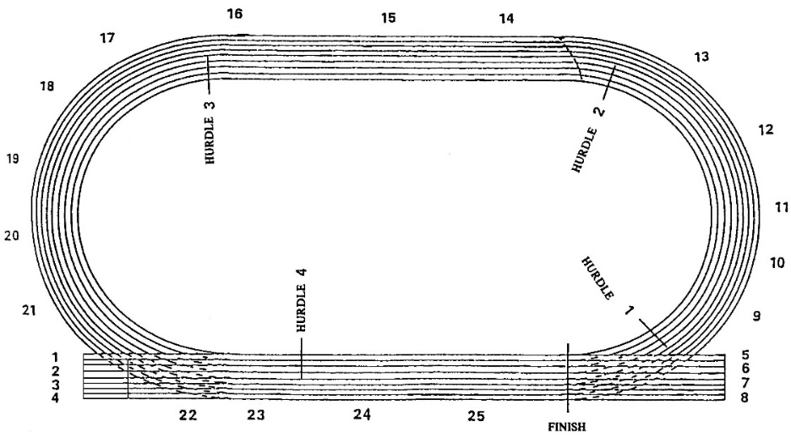
Please indicate on track plan the exact position of the infringement/incident

NOTE: Lane infringement “L” for wheelchairs/ frame runners:

Wheelchairs: Athlete is allowed 2 further pushes on the push rim from the first contact point on the left line to return to his/her lane before a DQ is applied.

